

**Artificial Intelligence and Data Science Department.**

OS / Even Sem 2021-22 / Experiment 4.

**___________________________________________________**

YASH SARANG.

47 / D6AD.

EXPERIMENT - 4.

System Call

**___________________________________________________**

**Aim:** Create a child process in Linux using the fork system call. From the child process obtain the process ID of both child and parent by using getpid and getppid system calls. Explore wait and waitpid before termination of process.

**___________________________________________________**

**Theory:**

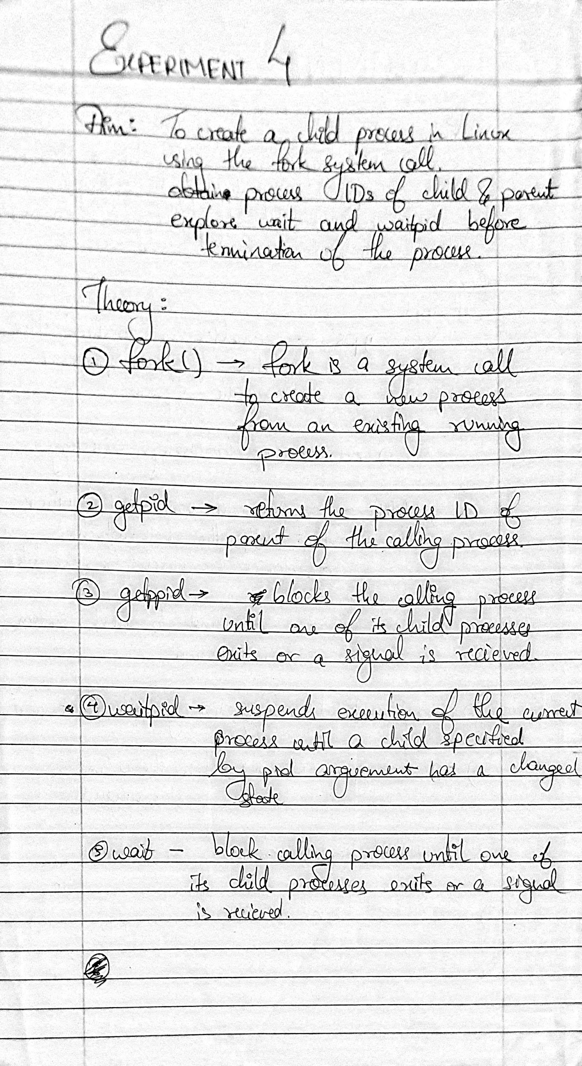

**___________________________________________________**

**Snippets:**

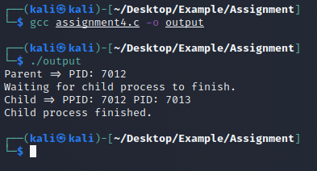

**___________________________________________________**

Conclusion:-

Thus we have implemented System Calling in Linux.

**___________________________________________________**